**4.** Use the function paste to create the following character vectors of length 30.

**(a)** “Label1”,”Label2”,”……..Label30”).

**Answer 4(a) : paste("Label",1:30)**

**(b)** (”FN1”,”FN2”,…….,”FN30”).

**Answer(4b): paste("FN",1:30,sep = "")**

**5.** calculate the amount of money owed after n years, where n changes from 1 to 15 in yearly increments, if the money lent originally is 10000 Rupees and the interest rate remains constant throughout period at 11.5%.

**Answer 5**: formula:

> P<-10000

> R<-11.5

> N<-(1:15)

**> Amount=P*(1+R/100)^N**

**> Amount**

**[1] 11150.00 12432.25 13861.96 15456.08 17233.53 19215.39 21425.16 23889.05**

**[9] 26636.29 29699.47 33114.91 36923.12 41169.28 45903.75 51182.68**

**>**

**6.**

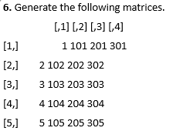

**Answer 6:**

**B=matrix(**

**+ c(1,101,201,301,2,102,202,302,3,103,203,303,4,104,204,304,5,105,205,305),**

**+ nrow=5,**

**+ ncol=4,**

**+ byrow=TRUE)**

>

> B

[,1] [,2] [,3] [,4]

[1,] 1 101 201 301

[2,] 2 102 202 302

[3,] 3 103 203 303

[4,] 4 104 204 304

[5,] 5 105 205 305

>

**7.**

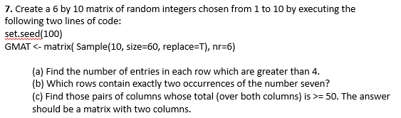

**Answer:**

>

> set.seed(100)

> GMAT<-matrix(sample(10,size = 60,replace = T),nr=6)

> View(GMAT)

**a) apply(GMAT,1,function(x){sum(x>4)})**

[1] 5 4 7 5 7 6

**b)** **which (apply(GMAT,1,function(x){sum(x==7)==2}))**

[1] 2 5

**c)** **GMATColSums <-colSums(GMAT)**

**which(outer(GMATColSums,GMATColSums,"+")>=50, arr.ind = T)**

row col

[1,] 2 1

[2,] 3 1

[3,] 4 1

[4,] 5 1

[5,] 6 1

[6,] 7 1

[7,] 8 1

[8,] 1 2

[9,] 2 2

[10,] 3 2

[11,] 4 2

[12,] 5 2

[13,] 6 2

[14,] 7 2

[15,] 8 2

[16,] 9 2

[17,] 10 2

[18,] 1 3

[19,] 2 3

[20,] 3 3

[21,] 4 3

[22,] 5 3

[23,] 6 3

[24,] 7 3

[25,] 8 3

[26,] 10 3

[27,] 1 4

[28,] 2 4

[29,] 3 4

[30,] 4 4

[31,] 5 4

[32,] 6 4

[33,] 7 4

[34,] 8 4

[35,] 9 4

[36,] 10 4

[37,] 1 5

[38,] 2 5

[39,] 3 5

[40,] 4 5

[41,] 5 5

[42,] 6 5

[43,] 7 5

[44,] 8 5

[45,] 9 5

[46,] 10 5

[47,] 1 6

[48,] 2 6

[49,] 3 6

[50,] 4 6

[51,] 5 6

[52,] 6 6

[53,] 7 6

[54,] 8 6

[55,] 9 6

[56,] 10 6

[57,] 1 7

[58,] 2 7

[59,] 3 7

[60,] 4 7

[61,] 5 7

[62,] 6 7

[63,] 7 7

[64,] 8 7

[65,] 9 7

[66,] 10 7

[67,] 1 8

[68,] 2 8

[69,] 3 8

[70,] 4 8

[71,] 5 8

[72,] 6 8

[73,] 7 8

[74,] 8 8

[75,] 9 8

[76,] 10 8

[77,] 2 9

[78,] 4 9

[79,] 5 9

[80,] 6 9

[81,] 7 9

[82,] 8 9

[83,] 2 10

[84,] 3 10

[85,] 4 10

[86,] 5 10

[87,] 6 10

[88,] 7 10

[89,] 8 10

>

>